**Significance of Autosar Architecture**

The number of electronic/ electric systems and the complexity of these systems are increasing in modern vehicles. The increasing complexity of the vehicle network is the motivation behind the development of AUTOSAR.

Modern vehicles have [more than a hundred ECUs](https://www.quora.com/How-many-ECUs-are-in-a-car)each. Every one of them has thousands of functions. Without following the standard, software development is most likely to be rewritten when the ECU hardware design is changed.

Autosar facilitates software development independent of hardware, with the standard software is more transferable. This means software can be easily shared between different vehicle systems largely independent of the system’s underlying hardware, which AUTOSAR improved by standardizing component interaction. In the past, and still today, most component software is developed according to the hardware it will be programmed on. AUTOSAR reduces this constraint by implementing a standardized interface between application software and its hardware to allow for hardware-independent component software. The standardized interface allows application software to communicate by utilizing a Virtual Function Bus (VFB).

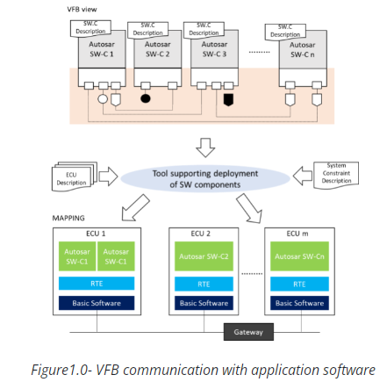

#### Overview of Layered Autosar Architecture

The AUTOSAR Architecture distinguishes on the topmost abstraction level between three software layers:

1. Application Layer,
2. Runtime Environment and
3. Basic Software (which run on a Microcontroller)

